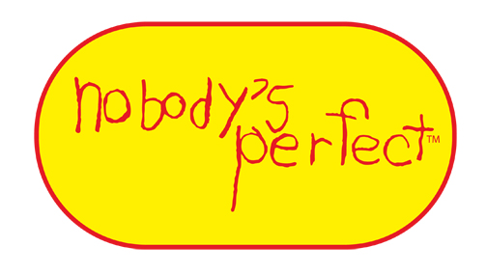
NOBODY’S PERFECT PARENTING PROGRAM Order Form

www.familiescanada.ca/resources-and-publications/

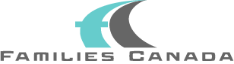

Formerly: Canadian Association of Family Resource Programs

Families Canada
Tel: | 1 613 237 7667
Toll free: | 1 866 637 7226
Fax: | 1 613 237 8515
Email: | publications@familiescanada.ca
Website: | www.familiescanada.ca

149-150 Isabella St
Ottawa, ON K1S 1V7

Payment must be received prior to shipment. Allow one month for delivery from order date.
PLEASE INDICATE YOUR TRAINING START DATE(S)

NOBODY’S PERFECT Parent Kit | Quantity | Price | Total
English |  | $22.00 CAD |  | A
French |  | $22.00 CAD |  | B
Sub-Total C (A + B) |  |  |  | C
Postage and Handling (15% of Sub-total C) |  |  |  | D
Sub-Total E (C + D) |  |  |  | E
GST (5%) applicable on Sub-total E |  |  |  | F
Sub-Total G (E + F) |  |  |  | G
Membership in Families Canada: $100.00 CAD |  |  |  | H
Total (G + H)
Please Print (Billing Address) Payment Method
Name |  |  |  | Visa/ MasterCard OR  Cheque or money order payable to Families Canada in $ CAD
Organization |  |  | Name on Card
Address |  |  | Signature
Telephone |  |  | Expiry Date |  | (month/year)
Email |  |  | Card Number

Please check this box to indicate that trained instructor
will offer the Nobody’s Perfect Parenting Program.
Revised: June 14, 2018
If Parent Kits are to be shipped to a location(s) other than your Billing Address, please complete the form below for each additional address.

Organization | Name | Delivery Address, Town, Province, Postal Code | Telephone and Email | Quantity  (English) | Quantity  (French)

